**Libraries Used**

1. **NumPy:**

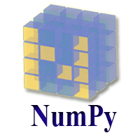

NumPy (**Numerical Python**) is an open-source Python library that is used in almost every field of science and engineering. It is the universal standard for working with numerical data in Python, and it’s at the core of the scientific Python and PyData ecosystems. NumPy users include everyone from beginning coders to experienced researchers doing state-of-the-art scientific and industrial research and development. The NumPy API is used extensively in Pandas, SciPy, Matplotlib, scikit-learn, scikit-image and most other data science and scientific Python packages.

**2.Pandas:**



Pandas is an open-source Python Library providing high-performance data manipulation and analysis tool using its powerful data structures. The name Pandas is derived from the word Panel Data – an Econometrics from Multidimensional data.

In 2008, developer Wes McKinney started developing pandas when in need of high performance, flexible tool for analysis of data.

Prior to Pandas, Python was majorly used for data munging and preparation. It had very little contribution towards data analysis. Pandas solved this problem. Using Pandas, we can accomplish five typical steps in the processing and analysis of data, regardless of the origin of data — load, prepare, manipulate, model, and analyze.

Python with Pandas is used in a wide range of fields including academic and commercial domains including finance, economics, Statistics, analytics, etc.

Key Features of Pandas

* Fast and efficient Data Frame object with default and customized indexing.
* Tools for loading data into in-memory data objects from different file formats.
* Data alignment and integrated handling of missing data.
* Reshaping and pivoting of date sets.
* Label-based slicing, indexing and sub Setting of large data sets.
* Columns from a data structure can be deleted or inserted.
* Group by data for aggregation and transformations.
* High performance merging and joining of data.
* Time Series functionality.

**3.Tensorflow:**

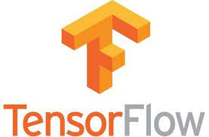

TensorFlow is an open-source software library for high performance numerical computation. Its flexible architecture allows easy deployment of computation across a variety of platforms (CPUs, GPUs, TPUs), and from desktops to clusters of servers to mobile and edge devices.

Originally developed by researchers and engineers from the Google Brain team within Google's AI organization, it comes with strong support for machine learning and deep learning and the flexible numerical computation core is used across many other scientific domains. TensorFlow is licensed under [Apache 2.0](https://github.com/tensorflow/tensorflow/blob/master/LICENSE).

**4.Sklearn:**

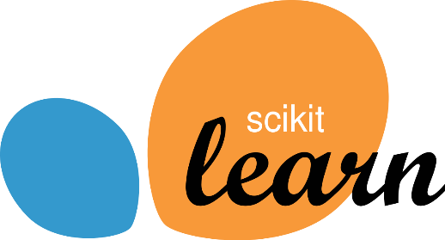

We will learn about the sklearn library and how to use it to implement machine learning algorithms. In the real world, we don't want to construct a challenging algorithm each time we need to utilise it. Although creating an algorithm from the beginning is a terrific approach to grasping the underlying concepts behind how it operates, we might not achieve the efficiency or dependability we require.

A Python module called Scikit-learn offers a variety of supervised and unsupervised learning techniques. It is based on several technologies you may already be acquainted with, including NumPy, pandas, and Matplotlib.

French research scientist David Cornopean’s scikits.learn is a Google Summer of Code venture where the scikit-learn project first began. Its name refers to the idea that it's a modification to SciPy called "SciKit" (SciPy Toolkit), which was independently created and published. Later, other programmers rewrote the core codebase.

The French Institute for Research in Computer Science and Automation at Rocquencourt, France, led the work in 2010 under the direction of Alexandre Gramfort, Gael Varoquaux, Vincent Michel, and Fabian Pedregosa. On February 1st of that year, the institution issued the project's first official release. In November 2012, scikit-learn and scikit-image were cited as examples of scikits that were "well-maintained and popular". One of the most widely used machine learning packages on GitHub is Python's scikit-learn.

Scikit-learn is mainly coded in Python and heavily utilizes the NumPy library for highly efficient array and linear algebra computations. Some fundamental algorithms are also built in Cython to enhance the efficiency of this library. Support vector machines, logistic regression, and linear SVMs are performed using wrappers coded in Cython for LIBSVM and LIBLINEAR, respectively. Expanding these routines with Python might not be viable in such circumstances.

Scikit-learn works nicely with numerous other Python packages, including SciPy, Pandas data frames, NumPy for array vectorization, Matplotlib, seaborn and plotly for plotting graphs, and many more.

**Key concepts and features include:**

* Algorithms for making decisions, such as:

Data are identified and categorised by classification as per the patterns.

Regression is the process of forecasting or predicting data values using the historical and anticipated data average.

Clustering is the automatic collection of datasets with related data.

* Predictive analysis is supported by various algorithms, including neural networks for pattern recognition and straightforward linear regression.
* Compatibility with the libraries of NumPy, pandas, and matplotlib

A predictive model can be built or trained on input data by computers using machine learning (ML), eliminating the need for explicit programming. A subset of AI is machine learning (AI).

Let us examine its revision history-

* May 2019: scikit-learn 0.21.0
* March 2019: scikit-learn 0.20.3
* December 2018: scikit-learn 0.20.2
* November 2018: scikit-learn 0.20.1
* September 2018: scikit-learn 0.20.0
* July 2018: scikit-learn 0.19.2
* July 2017: scikit-learn 0.19.0

The extensive community of open-source programs is one of the key justifications for using them, and Sk-learn is comparable in this regard. There have been roughly 35 contributors to Python's scikit-learn library, with Andreas Mueller being the most noteworthy.

On the scikit learn the main page, many Organizations, including Evernote, India, and A Weber, are listed as customers. But the actual utilization is much higher than that.

Along with these groups, there are communities all around the world.

**Scikit-learn’ s salient characteristics are:**

* The package provides the functions for data mining and machine learning algorithms for data analysis that are easy to use and effective. Support vector machines, gradient boosting, random forests, k-means, and other regression, classification, and clustering algorithms are included.
* The package is open source, accessible to everyone and reusable in several contexts.
* It is built on top of SciPy, Matplotlib, and NumPy.
* The package has a commercially usable - BSD license.

**5.OS (Operating System):**

It is possible to automatically perform many operating system tasks. The OS module in Python provides functions for creating and removing a directory (folder), fetching its contents, changing and identifying the current directory, etc.

You first need to import the os module to interact with the underlying operating system. So, import it using the import os statement before using its functions.

**6.OpenCV:**

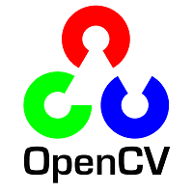**s**

OpenCV is an open-source software library for computer vision and machine learning. The OpenCV full form is Open Source Computer Vision Library. It was created to provide a shared infrastructure for applications for computer vision and to speed up the use of machine perception in consumer products. OpenCV, as a BSD-licensed software, makes it simple for companies to use and change the code. There are some predefined packages and libraries that make our life simple and OpenCV is one of them.

Gary Bradsky invented OpenCV in 1999 and soon the first release came in 2000. This library is based on optimised C / C++ and supports Java and Python along with C++ through an interface. The library has more than 2500 optimised algorithms, including an extensive collection of computer vision and machine learning algorithms, both classic and state-of-the-art.Using OpenCV it becomes easy to do complex tasks such as identify and recognise faces, identify objects, classify human actions in videos, track camera movements, track moving objects, extract 3D object models, generate 3D point clouds from stereo cameras, stitch images together to generate an entire scene with a high resolution image and many more.

Python is a user friendly language and easy to work with but this advantage comes with a cost of speed, as Python is slower to languages such as C or C++. So we extend Python with C/C++, which allows us to write computationally intensive code in C/C++ and create Python wrappers that can be used as Python modules. Doing this, the code is fast, as it is written in original C/C++ code (since it is the actual C++ code working in the background) and also, it is easier to code in Python than C/C++. OpenCV-Python is a Python wrapper for the original OpenCV C++ implementation.

The term Computer Vision (CV) is used and heard very often in artificial intelligence (AI) and deep learning (DL) applications. The term essentially means giving a computer the ability to see the world as we humans do.

Computer Vision is a field of study which enables computers to replicate the human visual system. As already mentioned above, It’s a subset of artificial intelligence which collects information from digital images or videos and processes them to define the attributes. The entire process involves image acquiring, screening, analysing, identifying and extracting information. This extensive processing helps computers to understand any visual content and act on it accordingly.

Computer vision projects translate digital visual content into explicit descriptions to gather multi-dimensional data. This data is then turned into a computer-readable language to aid the decision-making process. The main objective of this branch of artificial intelligence is to teach machines to collect information from pixels.